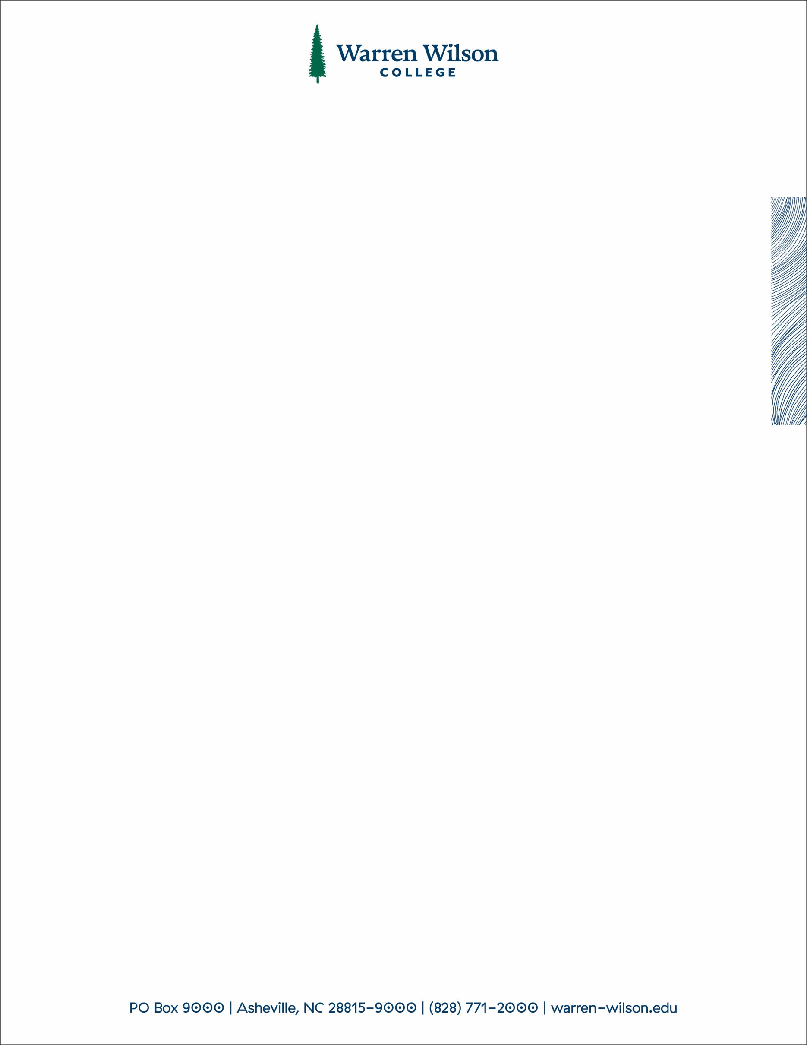

Syringe & Needle Disposal Policy

To ensure the safety of students, staff, and faculty, all community members who use injected medication (such as insulin) or use hypodermic syringes and needles for whatever reason, are required to dispose of them after use in approved sharps containers. There are several approved sharps container locations on campus (Gladfelter bathroom, Residence Halls, Student Health Center etc.)

Students, staff and faculty who wish to have their own sharps containers, can obtain them at no cost, from the Student Health Center.

For those with personal sharps containers, all syringes and needles should be placed in their approved sharps container; once their container is 2/3 full or once the contents rise to the FULL level marker on the container, the community member should return it to the Student Health Center (9am-5pm) for proper disposal or coordinate with Public Safety if the Health Center is closed.

**General Guidelines for Handling Syringes and Needles**

All syringes and needles should be disposed of via appropriate sharps containers that are installed on campus.

* Sharps containers installed on campus are emptied by the Health Center.
* Syringes and needles should never be disposed of in the trash or recycling. (This places an unfair risk of needle puncture on staff and students.)
* If you do not have a sharps container, a hard plastic container with lid can be used to transport syringes and needles to the Student Health Center.
* Never carry an uncapped needle around with you or place it in your pocket.
* **Do not** attempt to recap a needle that is not yours.
* **Do not** recycle or reuse needles or syringes.
* **Do not** flush used needles or syringes down the toilet.
* **Do not** use glass containers to dispose of needles or syringes.

Installed Sharp Container Locations:

* Gladfelter Bathrooms (Both)
* Dorland Laundry Room
* Sunderland Laundry Room
* Student Health Center