**UKG Ready Time – Hourly Employees**

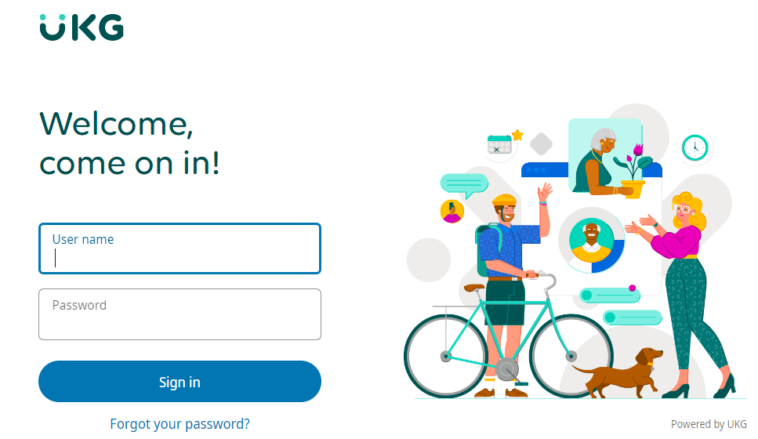

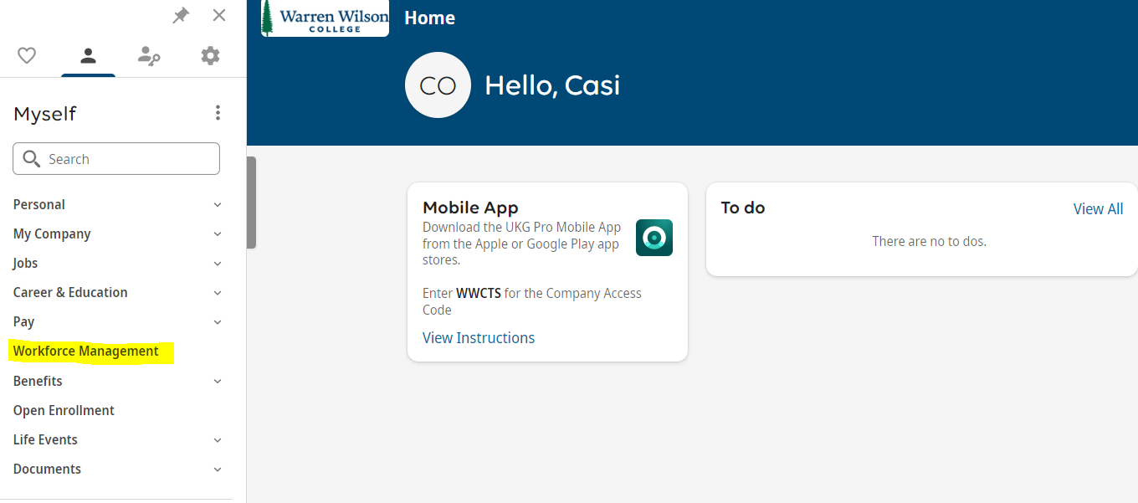

To access the Ready time module of UKG Pro **(Clock In & Clock Out)**, select **Workforce Management** under **Myself** in the side Menu of the Home page.

A new window opens to UKG’s Ready time module’s home page.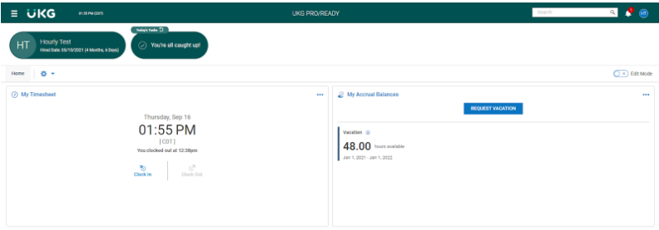

The Ready Home page consists of different sections and options.

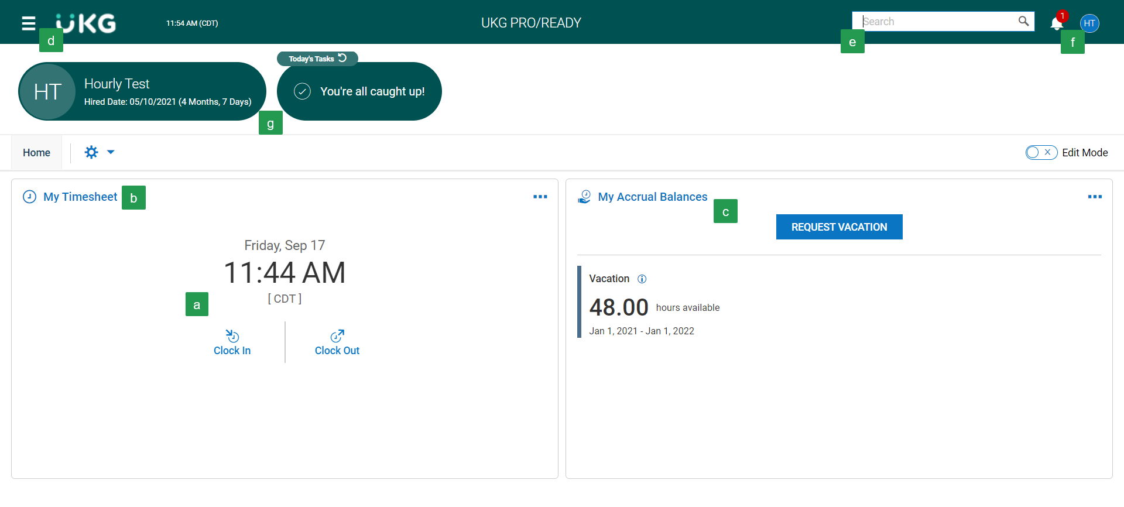

|  | Record your time by clicking on **Clock In** and **Clock Out** |
| --- | --- |
|  | Link to access your **timesheet** |
|  | Time off information. Includes access to your **balances** and link to **request time off**. |
|  | Drop-down **menu** to access your timesheet, time off, and viewing your profile. |
|  | **Search**/Navigation bar. |
|  | **Inbox**-notifications and to do items. |
|  | Your **information** and open **items**. |

To navigate within the UKG Ready you can use the hyperlinks from the Home page or use the My Info tab of the side menu.

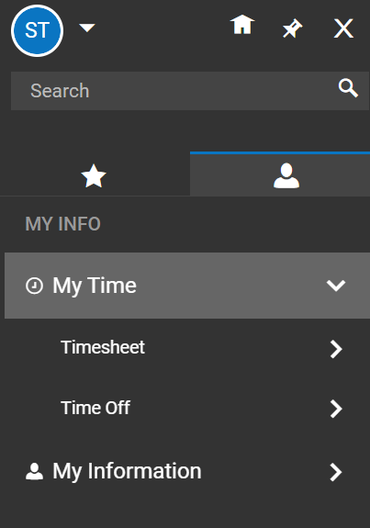

The **My Time** tab of the side menu allows you to access a variety of information regarding your timesheet and time off.

Under **My Time** the options include Timesheet and Time Off.

* **Timesheet** – Shows options to view current timesheet, historical timesheets and change requests.
* **Time Off** – Shows options for request, history, balances and calendar

Clocking In and Clocking Out

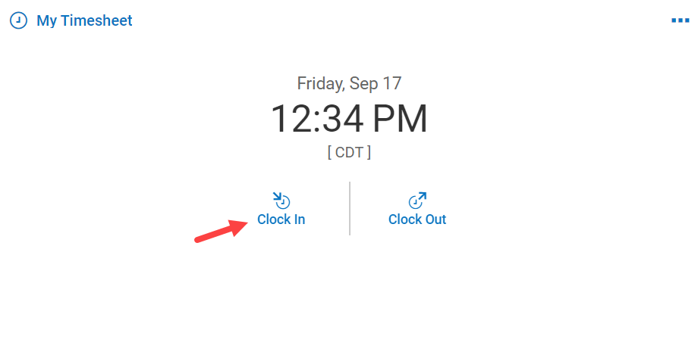

From the home page, click on Clock In when you arrive for the day and upon returning from lunch.

A confirmation message box with the recorded time will become visible.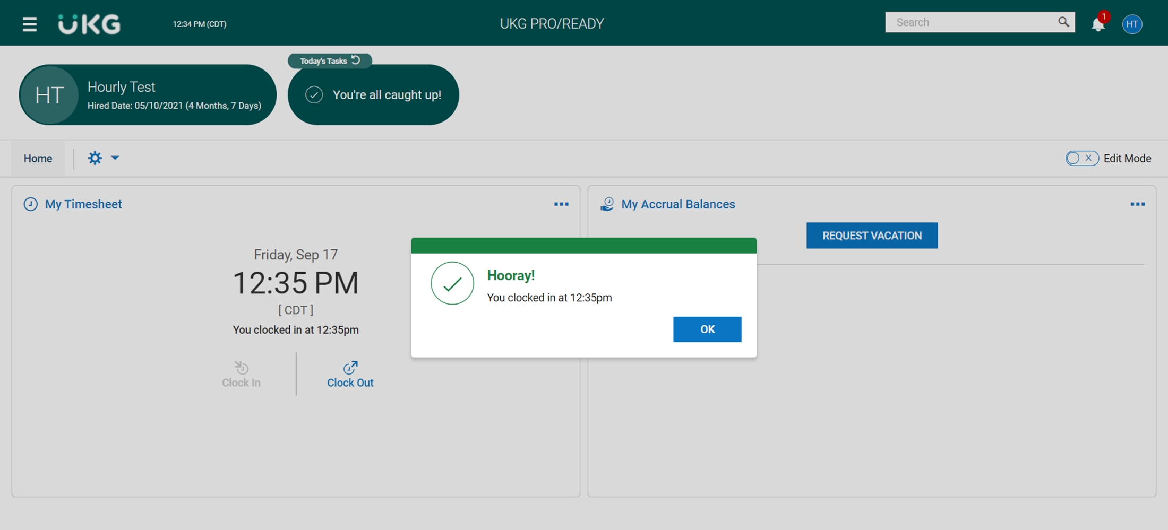

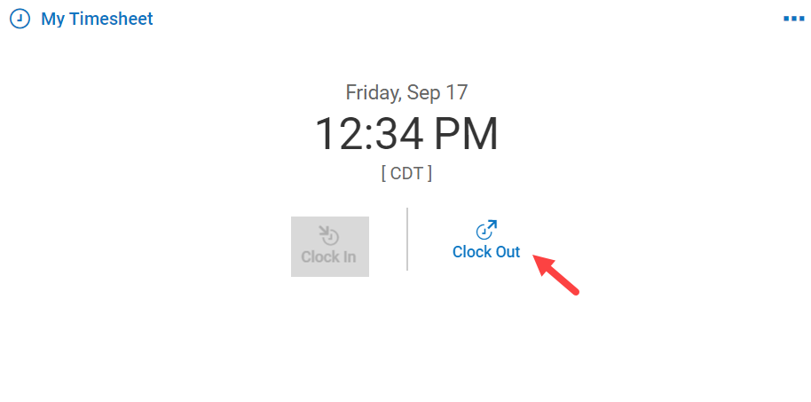

Follow the same process to clock out for lunch and when leaving at the day, but click on the Clock Out option.

Accessing Your Timesheet

You can access your timesheet by clicking on the quick link on the Home page or you can use the side menu.

From the Home page click on the My Timesheet link.

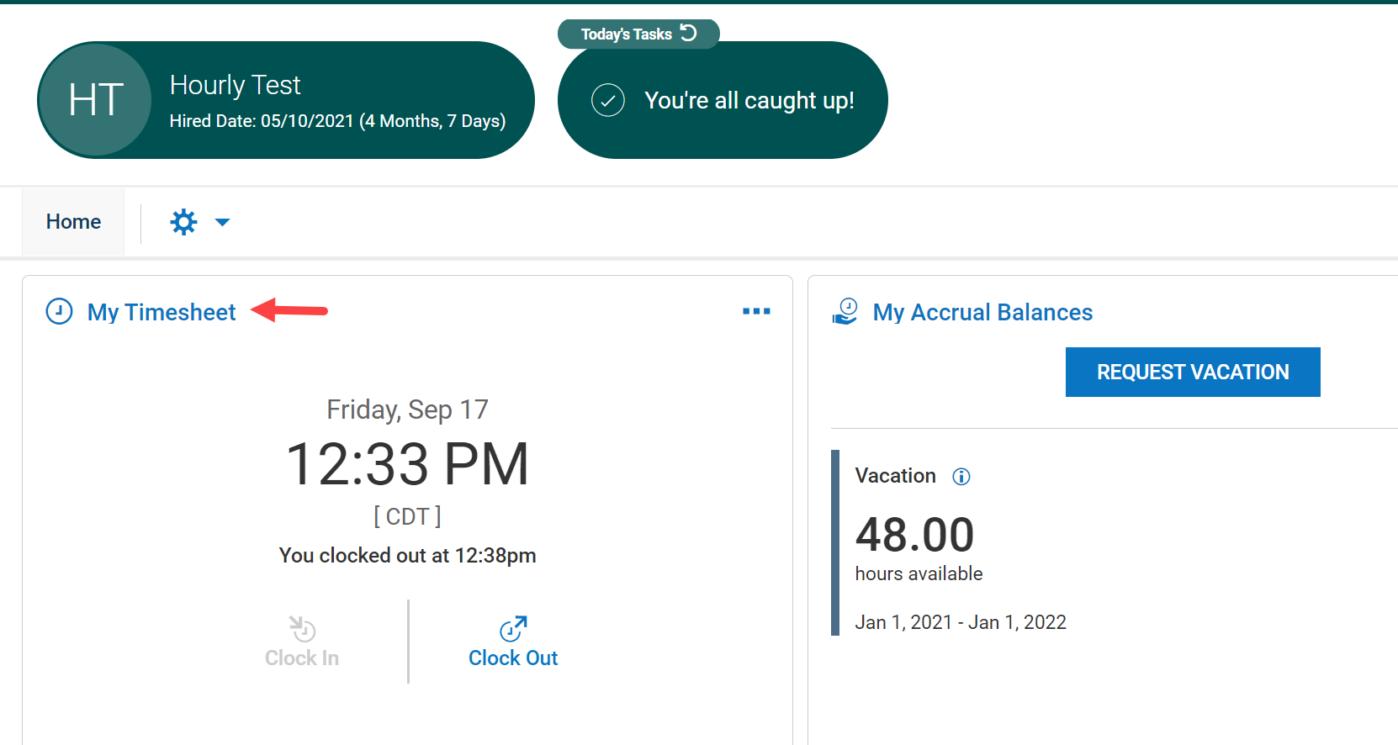

From the side menu. Navigation: My Info > My Time > Timesheet > Current Timesheet

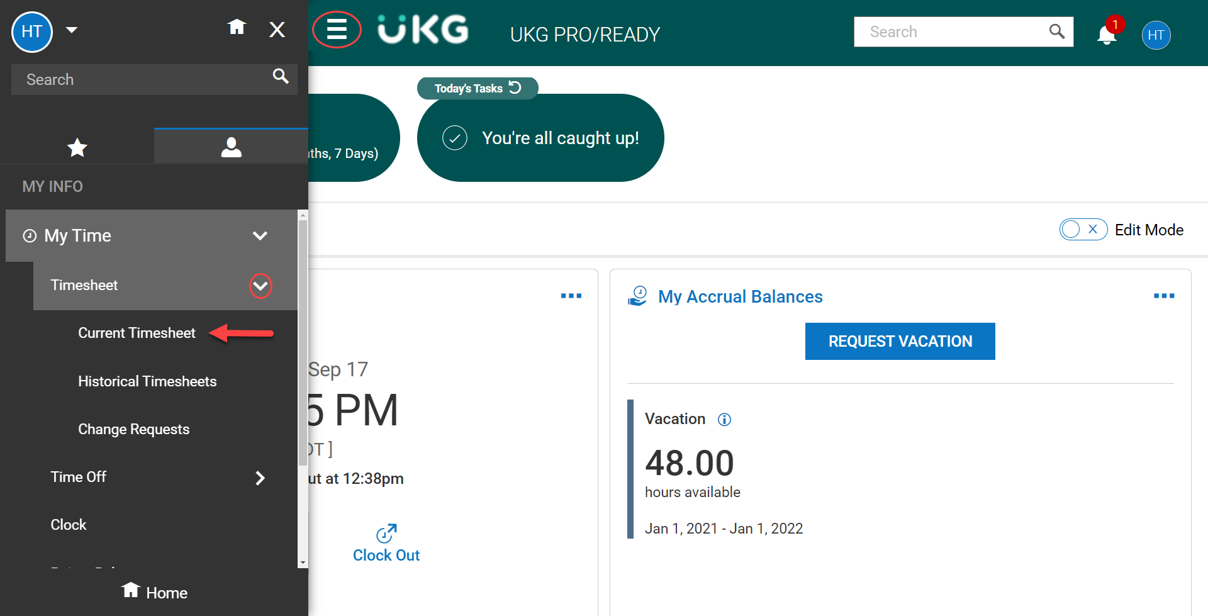

# 

# 

# 

# 

# 

# 

# 

# 

# 

# 

# **Viewing Your Timesheet**

The Timesheet Edit screen displays your timesheet for the entire pay period with any time that has been entered.

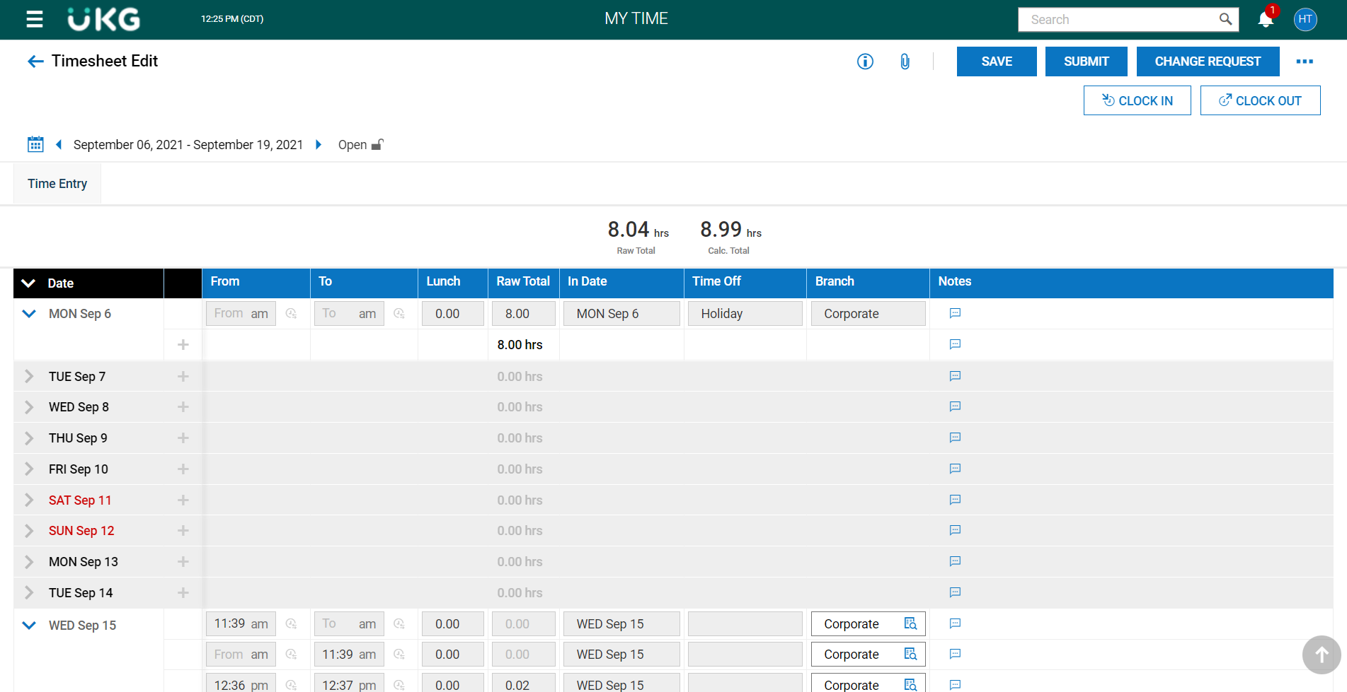

You have the ability to Clock In and Clock Out from your timesheet. If you have clocked in or out while in your timesheet you must click on the SAVE button.

If you need a correction or change to your timesheet, it must be done by your manager. To notify your manager of the request click on CHANGE REQUEST.

At the end of each pay period you need to submit your timesheet to your manager to review and approve. Submit your timesheet by clicking on SUBMIT.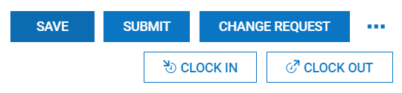

Below are the features of the timesheet.

| **A** | **Timesheet Tabs:** Expand this drop down to navigate to other timesheet information. |
| --- | --- |
| **B** | **Date:** Use the arrows to navigate between  pay periods or select the calendar icon to choose a specific date or range. |
| **C** | **Daily Information:** Expand or collapse time entry information related to each day of the  week. |
| **D** | **Time Entry Fields:** Enter or change information in available fields for a specific time entry. Greyed out fields can only be  changed using a Change Request. |
| **E** | **Note:** Select to view/add timesheet notes. |
| **F** | **Actions**: Common available actions include  **Save**, **Submit**, and **Change Request**. |

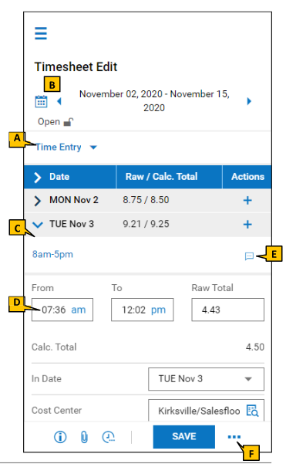

The Timesheet Edit page contains several tabs in addition to the timesheet. The tabs include:

* **Calc Detail** – Calculation details grouped by day (day total, week total, pay period)
* **Calc Summary**  - Calculation summary per code
* **Counters** – Calculation summary for each code on each day
* **Summary by Day** – Calculation totals per day

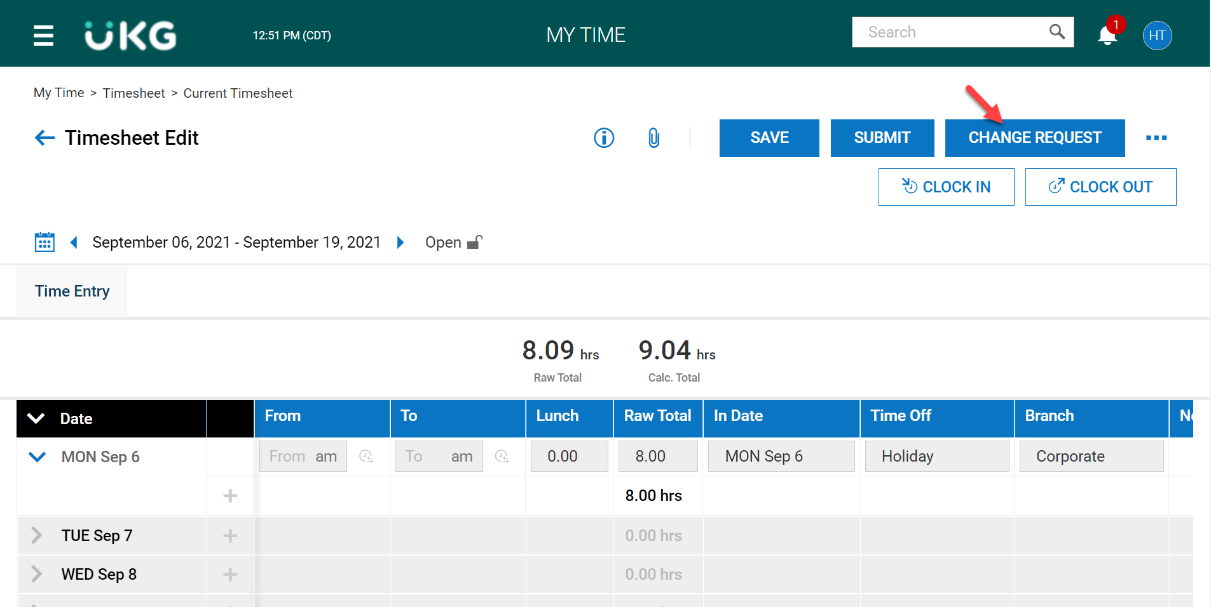

**Requesting a Change to Your Timesheet**

On the Timesheet Edit page, click on CHANGE REQUEST.

A Change Request pop-up box will open where you will enter the information for the request.

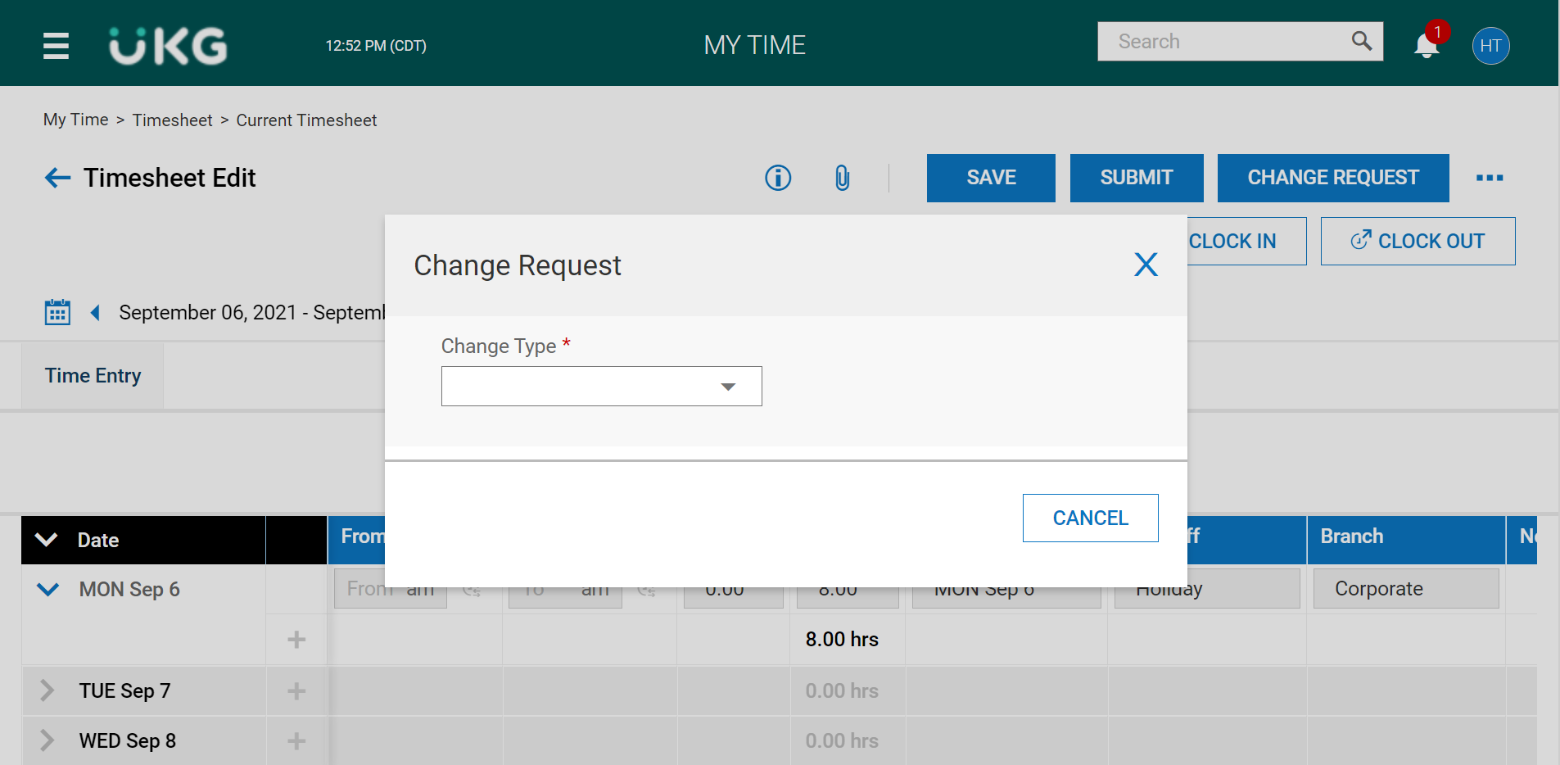

Select the Change Type from the drop-down menu.

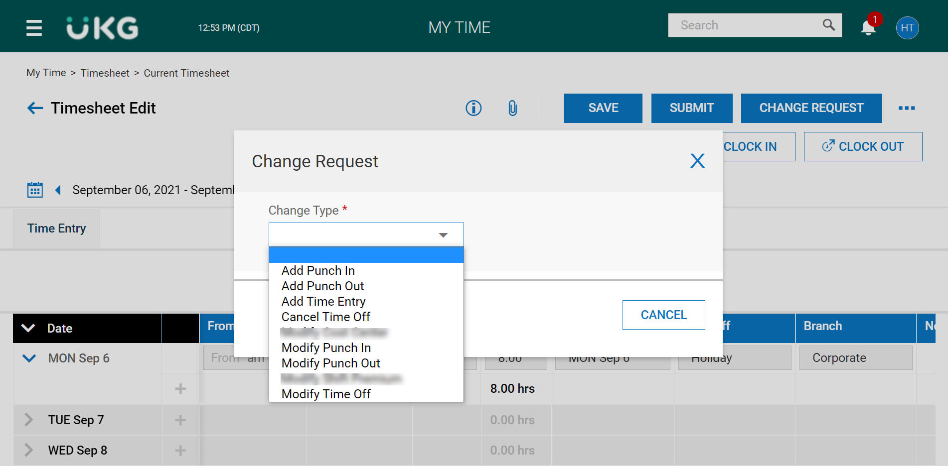

The Change Request box will expand to allow you to add additional details including the date to apply the change, the correct information in the To: field and add any comments.

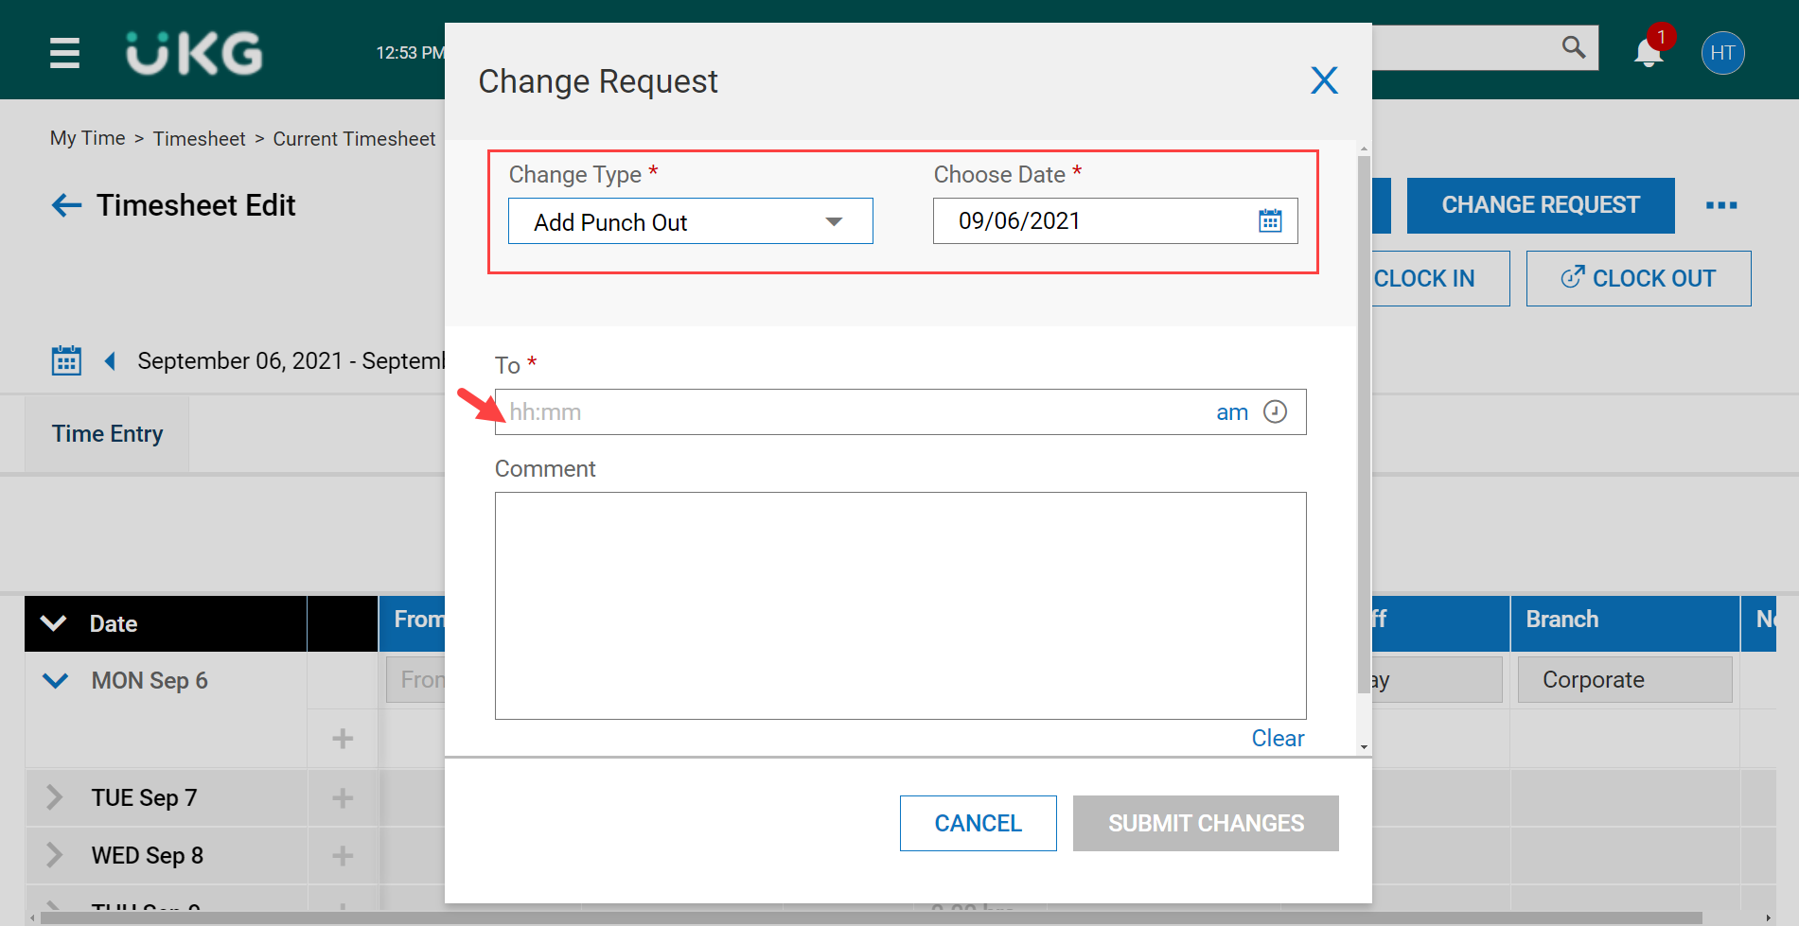

The Submit Changes button will not become active until the To: field is completed. Please make sure to verify if the time is am or pm.

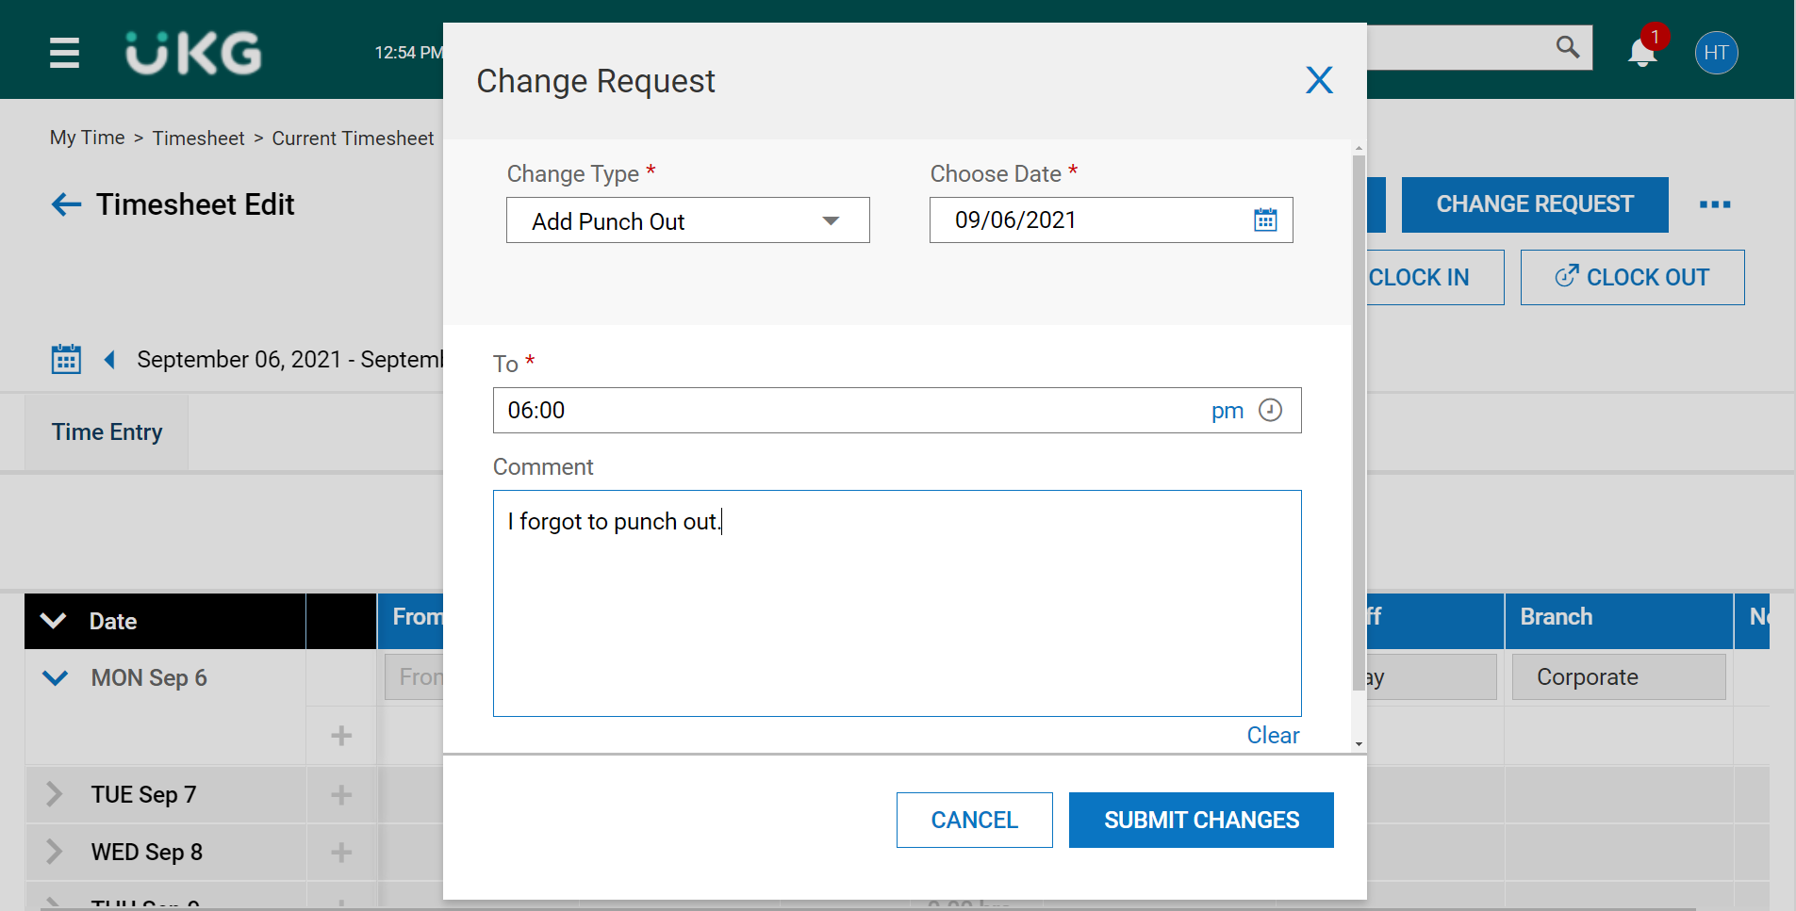

You will receive a confirmation message after you have clicked on the SUBMIT CHANGES button.

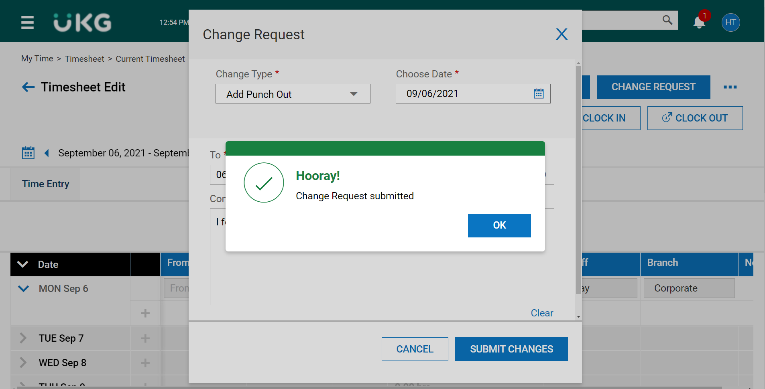

# **Submitting Your Timesheet for Approval**

At the end of each pay period you are required to submit your timesheet to your manager for review and approval. Before doing so, please make sure all time is accounted for and there are no errors.

To submit your timesheet, click on the SUBMIT button at the top of the page.

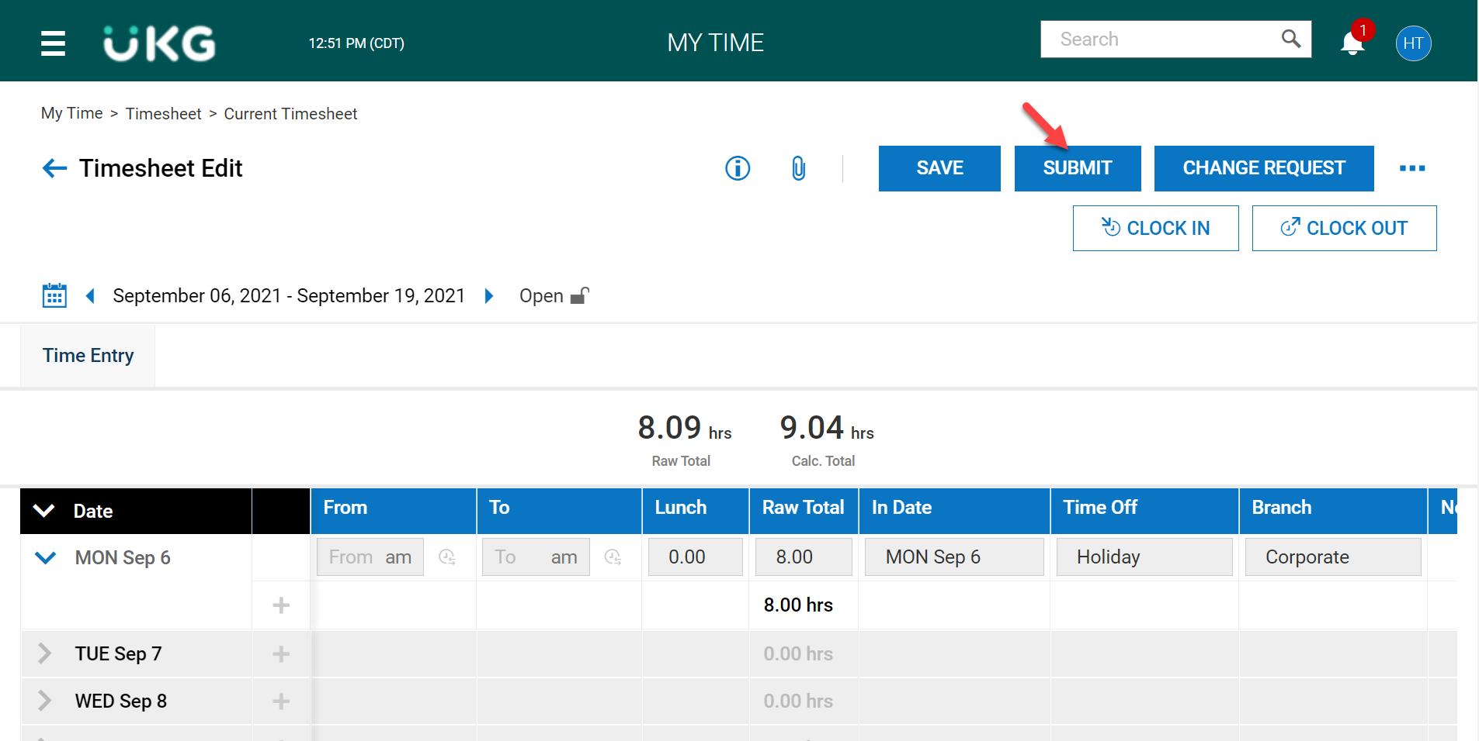

Once you submit your timesheet no modifications will be allowed. A pop-up notification will open for you to verify you’d like to continue.

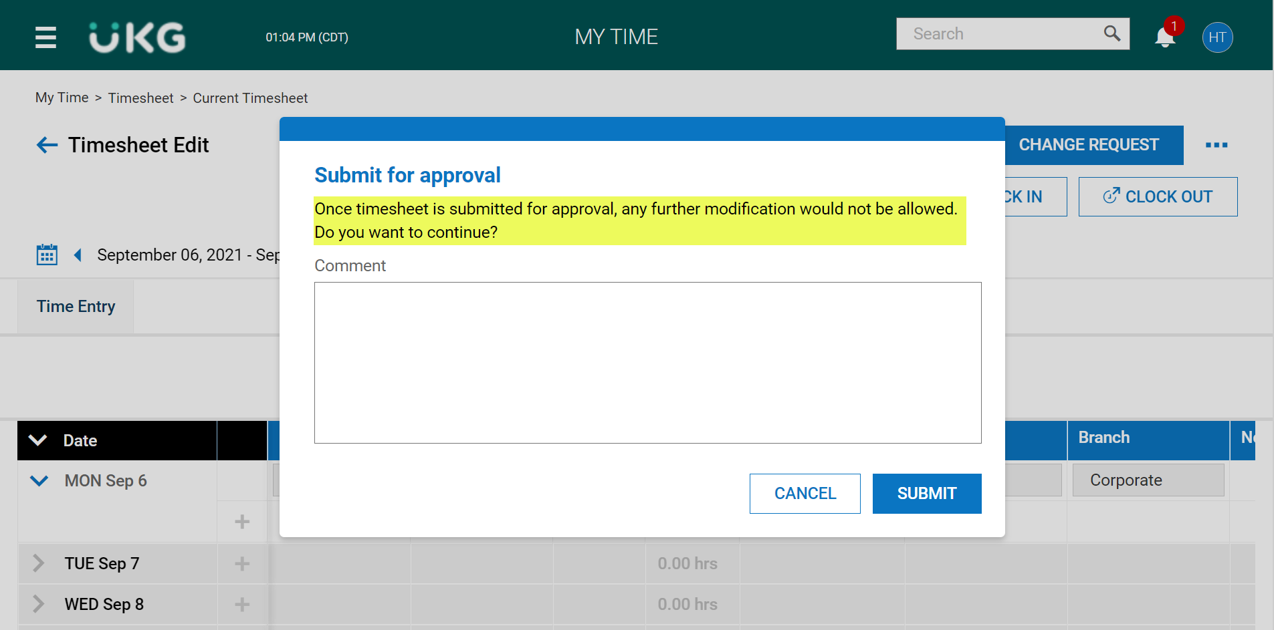

If all is accurate, click on the SUBMIT button.

If there are no errors you will see the confirmation message.

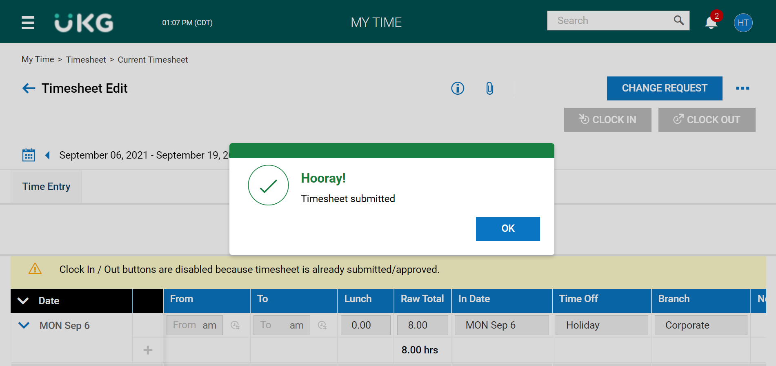

*Please note, once you have submitted your timesheet for approval, the Clock In and Clock Out buttons will be disabled for that pay period.

The status of your timesheet will show as Submitted.

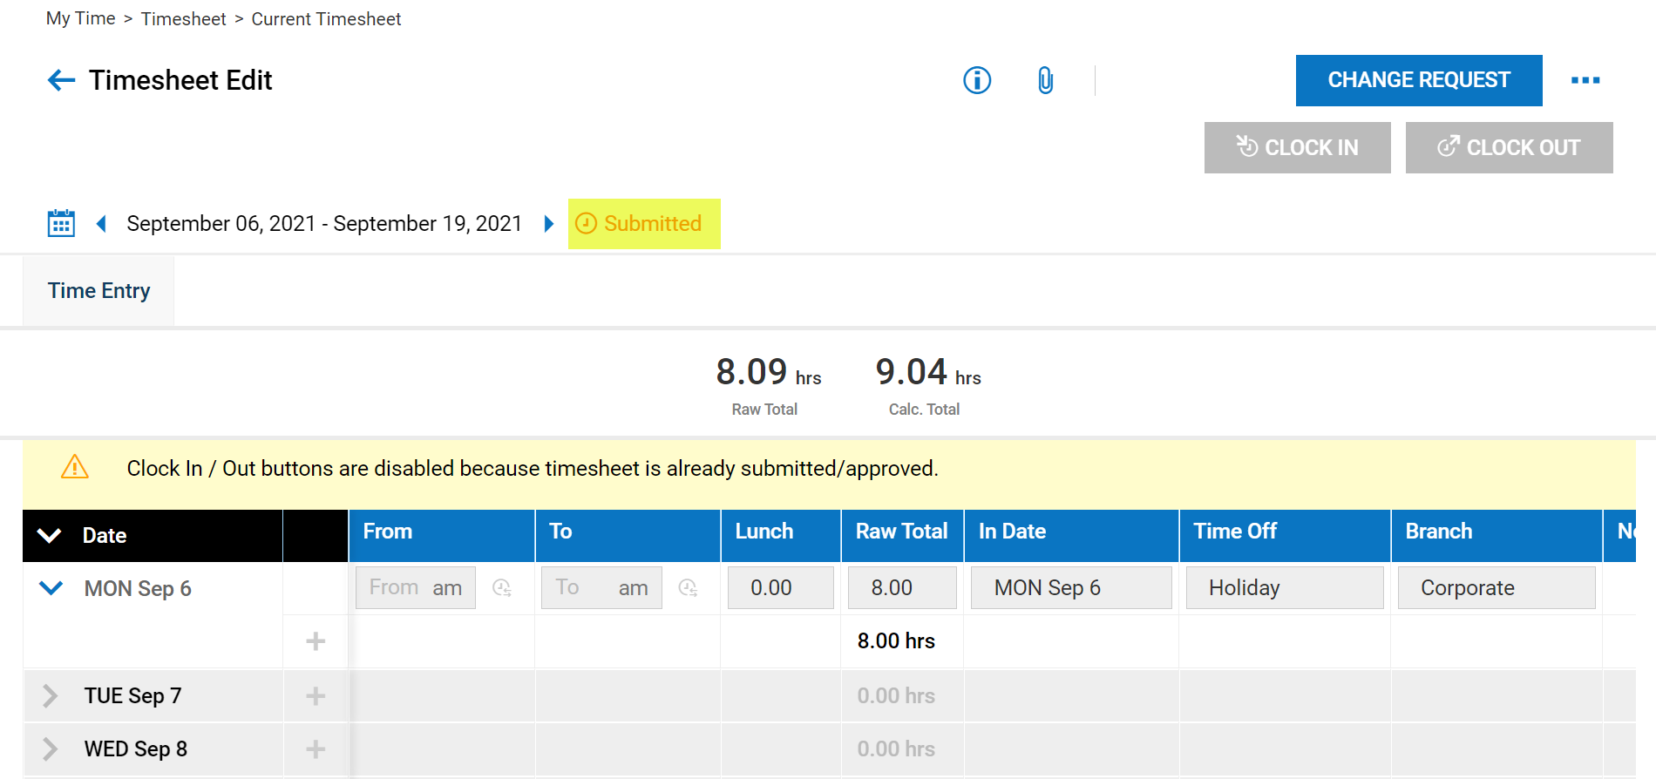

When your manager has approved your timesheet the status will change to Approved.

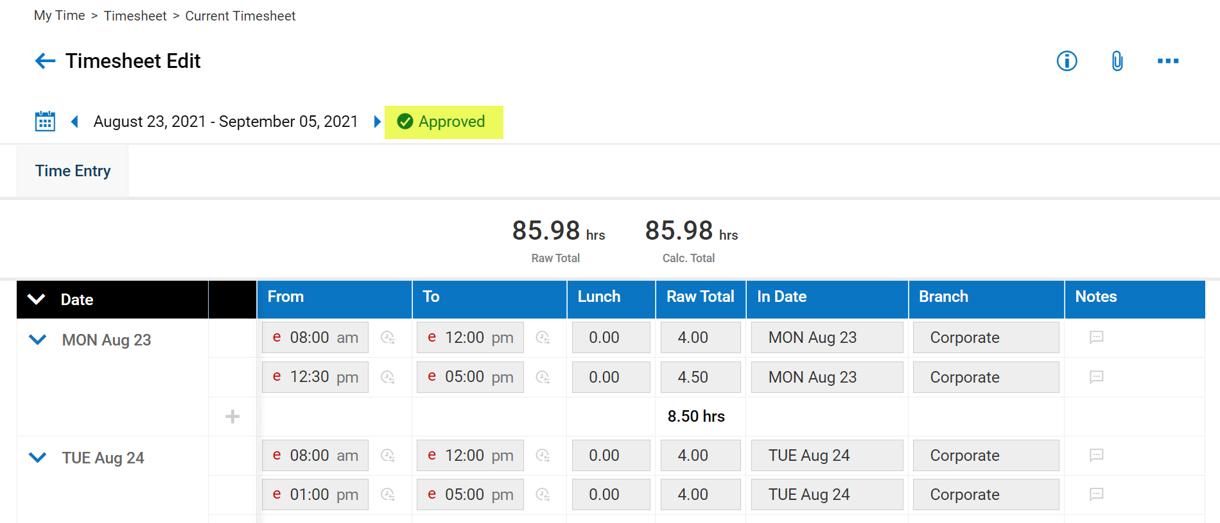

Requesting Time Off

You can request time off from either the Home page or by navigating to the side menu.

From the Home page click on the Request Vacation in the My Accrual Balances box.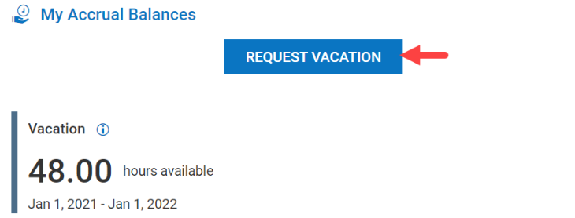

From the side menu navigate to My Info > My Time > Time Off > Request

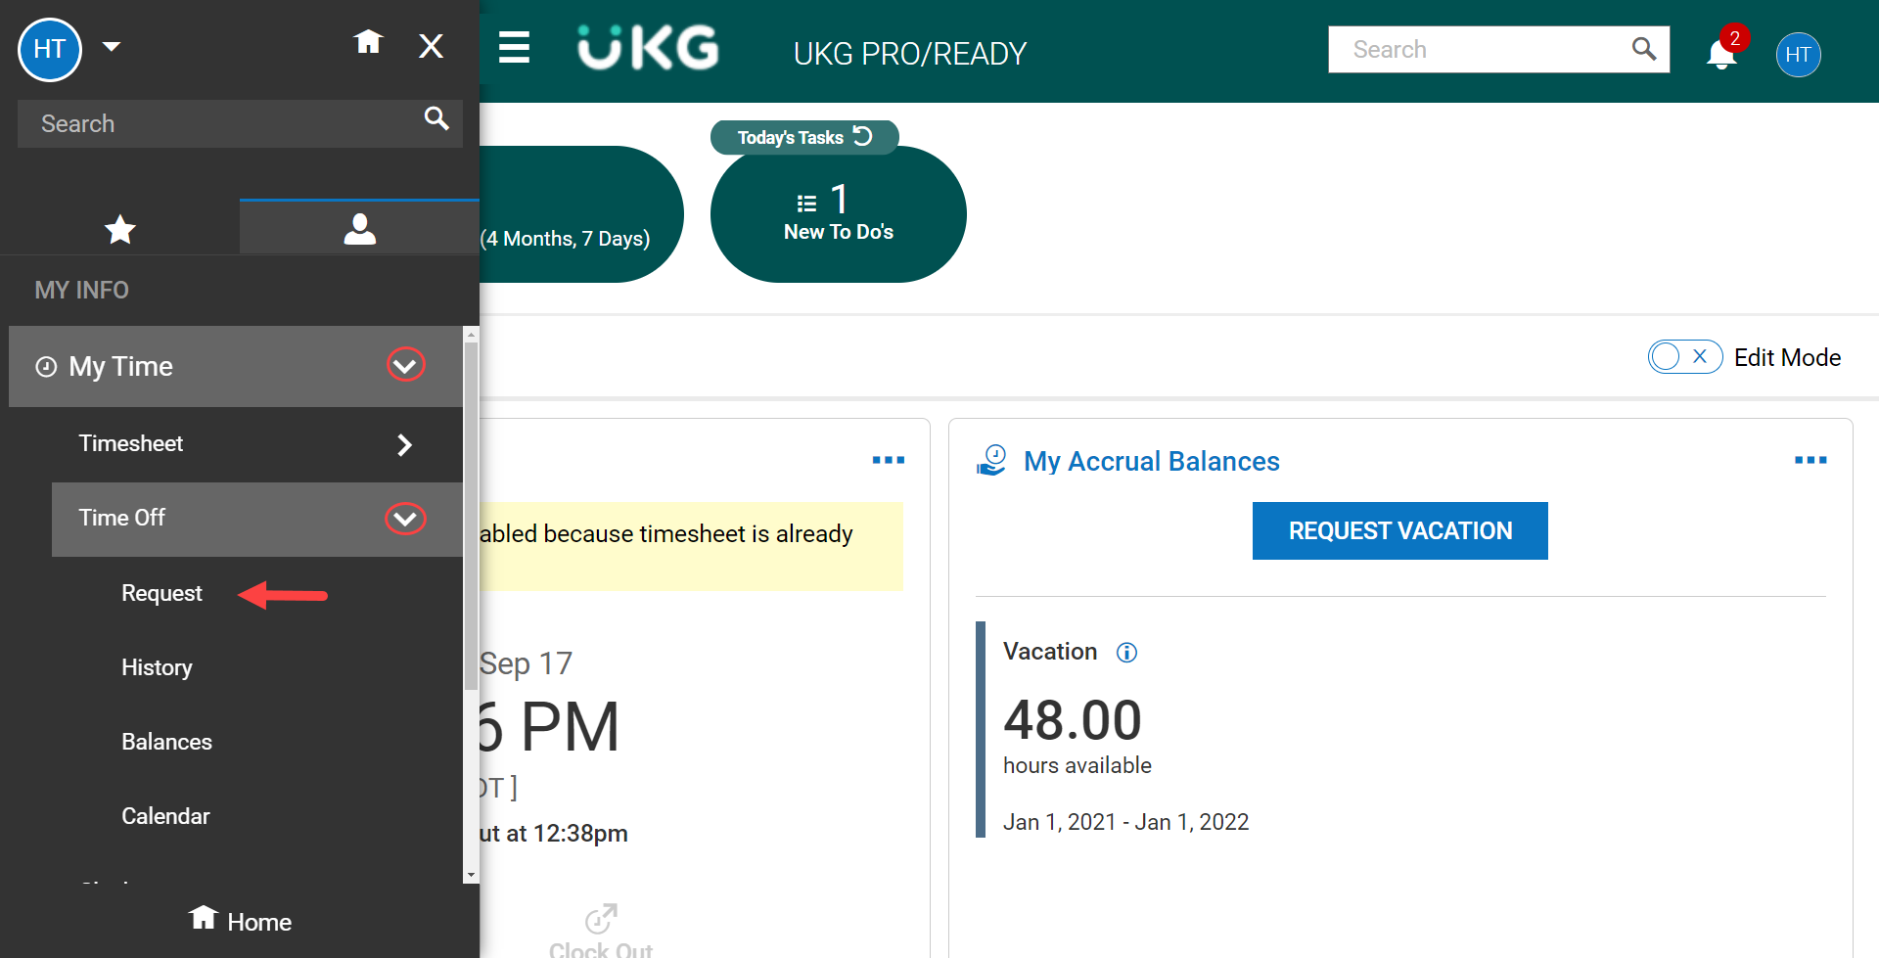

Enter the information on the Request page.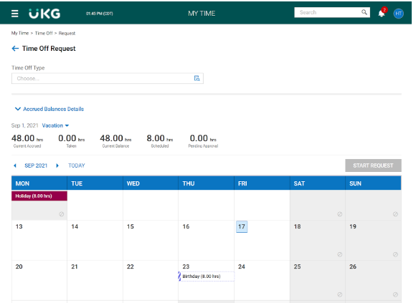

Select the **Time Off Type** drop-down and select desired Time Off Type (vacation, sick, etc). If you have

use the button on the Home page, it will be populated with that type.

# 

Select **Start Request**. You may select a date or range from the calendar and select **Start Request** and it will populate the date(s).

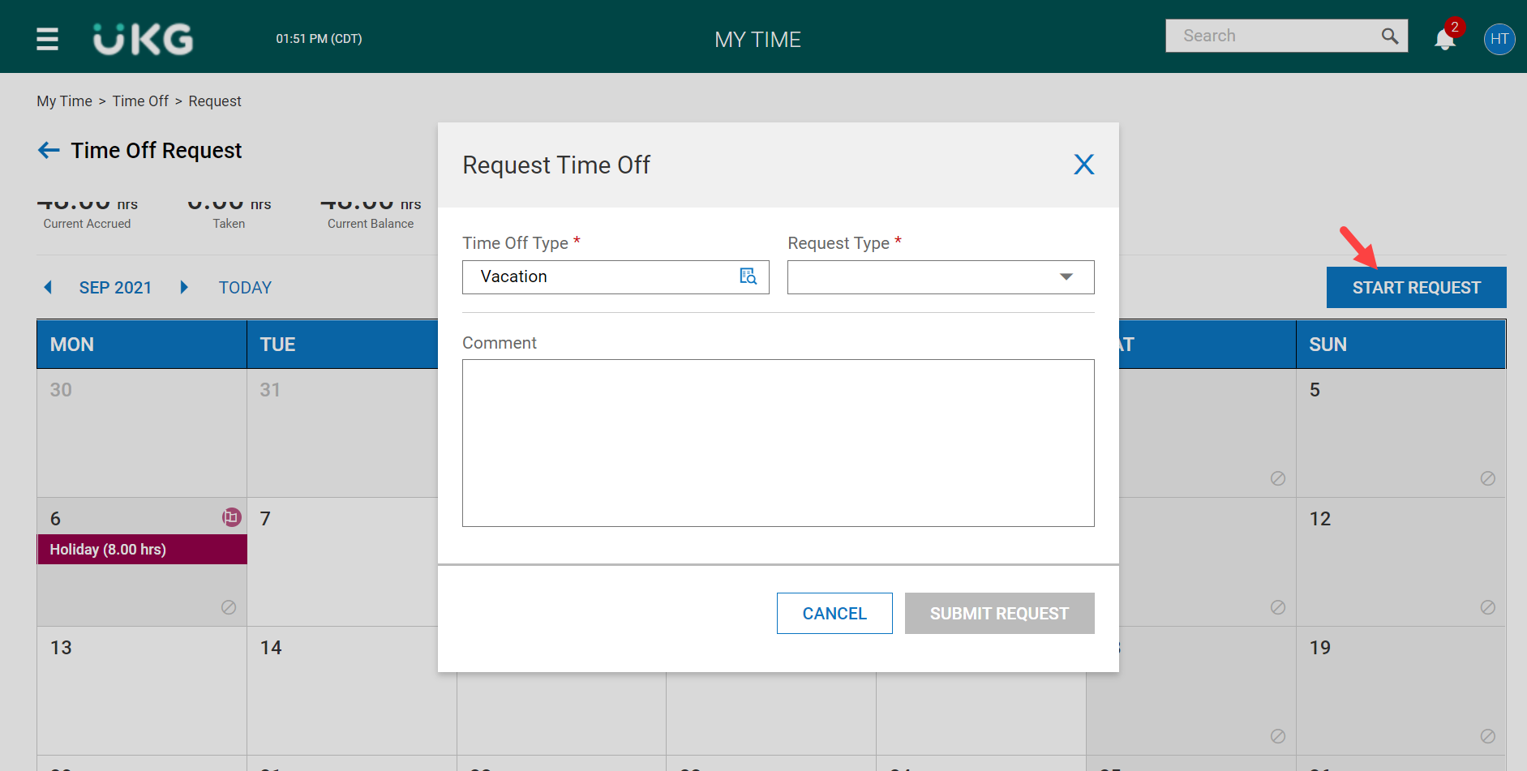

Select the **Request Type** drop-down and select from the following:

# **Full Day:** requesting the entire day.

* + **Multiple Days:** enter number of hours requested for each day.
  + **Partial Day (Bulk):** enter a total number of hours requested for the day.

The Date and Total Hours fields will become visible when the Request Type has been entered.

# Select date or range of request.

# 

Enter duration, time frame, or total hours.

Type a **Comment** (optional).

Select **Submit Request**.

Canceling a Time Off Request

From the side menu navigate to My Info > My Time > Time Off > Request



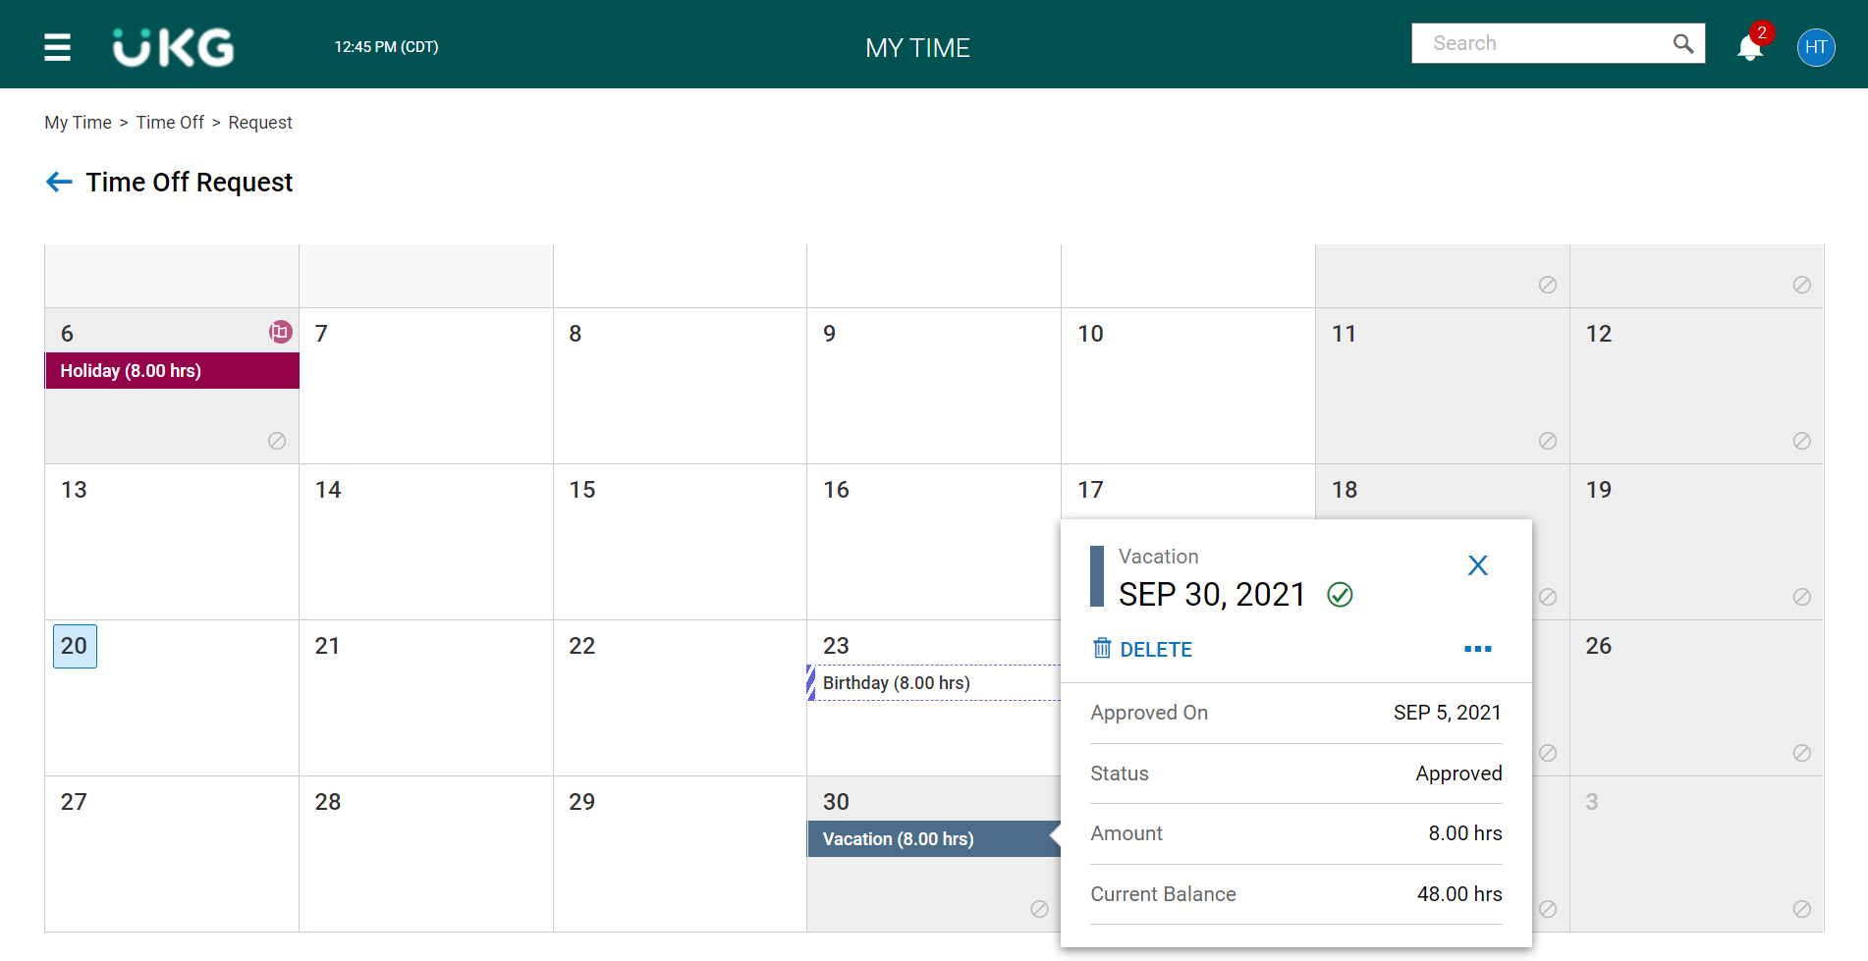

Locate the date on the calendar for the time off you’d like to cancel and click on the time off.

Click on Delete.

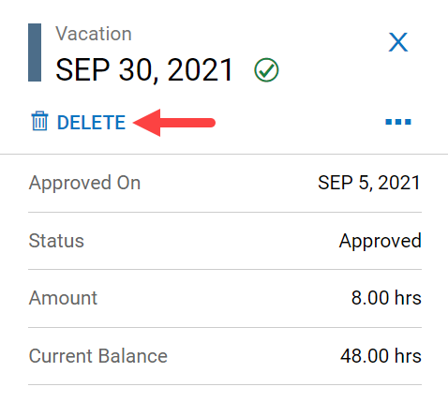

Select Delete from the verification message.

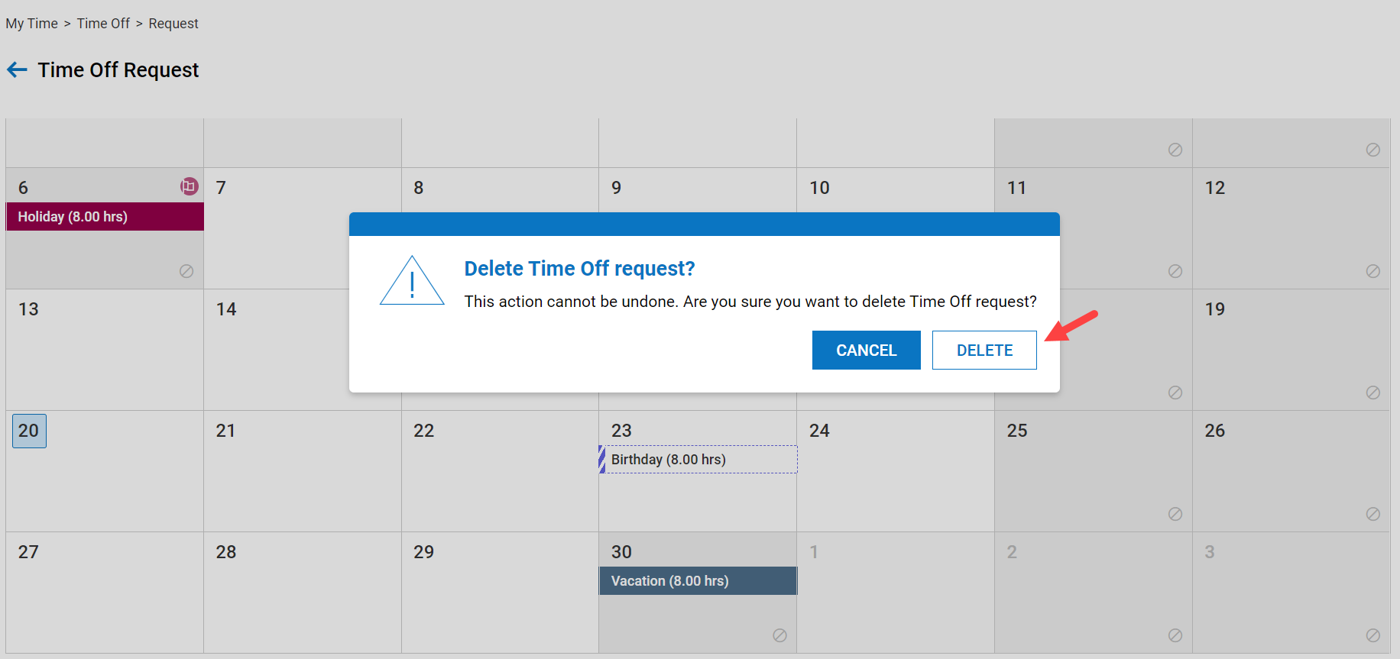

You will receive confirmation that it was successful.

